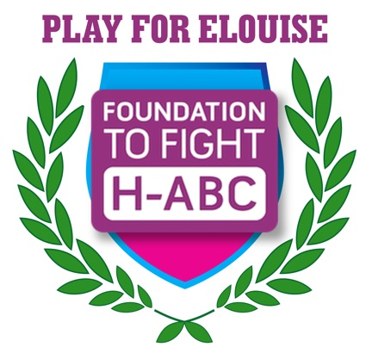 | Foundation to Fight H-ABC  501(c)3 Non-profit Organization  P.O. Box 12416  Silver Spring, MD 20908  www.h-abc.org

Event Date: Friday June 9, 2017, 6pm – 10pm

Location: Manor Country Club, 14901 Carrolton Road, Rockville MD
This great fundraising event entails an evening on the patio, with a great band, open bar, light food, and silent auction. Golf in the afternoon is separate, please call XX to sign up for golf.

The Foundation to Fight H-ABC’s event “Play for Elouise 2017” is in need of corporate or personal sponsors to offset overhead cost so more of the funds raised will go directly to the foundation.
Foundation History: Founded by Michele and Oscar Sloan in December, 2015, the Foundation to Fight H-ABC has had exceptional community support from those who have met their daughter, Elouise, who until age 3 appeared to be a healthy and happy toddler. Still very happy, Elouise's physical decline began with right-sided weakness and has progressed to an inability to stand on her own. Diagnosed with H-ABC, and now in the 5th grade, she is unable to do anything for herself physically, relying on her parents and the school team for assistance. Because of her now impaired motor-speech function, she receives speech-language therapy in addition to physical and occupational therapy sessions. While school was out for the summer, she underwent a hip realignment which had to be redone in December 2016.

Since launching its website in April, 2016, the Foundation to Fight H-ABC has strived to succeed in its outreach to the community (affected and non-affected families alike) and its dedication to the development of a better understanding of H-ABC. Fundraising for a newly diagnosed, rare disease has been a challenge. With the funds raised, the organization is developing an Annual Fund and is approaching foundations and corporations for significant gifts for H-ABC research. In addition to the Alexion Corporation, they have successfully appealed to The Bernard and Muriel Lauren and The Arcadipane Foundations. They are waiting to hear from The John and Maria Laffin Trust, and will approach the Buddy Candler Foundation in the near future. They firmly believe that the urgency of finding a cure for H-ABC will enable them to fund the research at the Children’s Hospital of Philadelphia; however, they also know that the compelling nature of this disease will enable their partner, the Children's Hospital of Philadelphia, to also raise significant support for their research. To date, the Sloan’s have personally funded $85,000 to various researchers to help keep the research moving, including Children’s Hospital of Philadelphia, Yale University, University of Wisconsin and University of Pittsburg, who are other partners in the research consortium and who are now actively involved directly in H-ABC research.

The Foundation to Fight H-ABC will not be deterred until all children are free from this overwhelming challenge. We welcome your support for this important effort.

BENEFITS
- You can claim a tax deductible donation, as we are a 501(c) 3 non-profit organization
- You will have a great advertising and publicity opportunity for your business via social media, e-mail, internet and possibly TV
- You will have a way to target your best customers and increase loyalty
- You will display your family or corporation’s “Good Will” to the community
- You will be a positive example to your children and community
- You will have the opportunity to network with successful business people and professionals in our communities

LEVELS OF SPONSORSHIP
- Official Sponsor $1000+ Receive 5 Tickets ($500 Value) to Play for Elouise 2017 evening event (golf tournament is separate). As an Official Sponsor Your name will be HIGHLIGHTED on the event signage, social media, and WEB SITE for ONE YEAR. You will receive 4 event t-shirts.
- Donor $500+ Receive 3 Tickets ( $300 Value) to Play for Elouise 2017 (golf tournament is separate). Your name will appear on the event signage, event signage, social media, Web Site for one year. You will receive 2 event t-shirts.
- Friend $250+ Receive 1 Tickets ( $100 Value/Event) to Play for Elouise 2017 (golf tournament is separate). Your name will appear on the event signage, and social media. You will receive 2 event t-shirts.

Sponsor Information
Sponsor Name or
Company Name:
 | Company Name/ Last Name | First Name | M.I.
Sponsorship level: | $250 | $500 | $1000

Address tax deductible receipt to be mailed:
 | Street Address | Apartment/Unit #

 | City | State | ZIP Code

Phone: |  | Email:

Can we thank you via Social Media Y/N? | Links to your website and social media:

Payment by Credit Card: | M / V / AE / D Name on Card:
 | Circle Type of Credit Card

Payment Information (if CHECK Make payable to: Charities Angels, INC.)
Number on Card:

Exp. date on Card
 | Address (if different than above) City | State | ZIP Code
NAME on Check: |  | Amount enclosed :

